**Lab Assignment**

**Using public/free API**

Name: Sadman Sakib

ID: 011183013

Course: Software Engineering Lab

Sec: A

API used: <https://developer.nytimes.com/docs/articlesearch-product/1/overview> (Article search API)

Tools used: HTML, Bootstrap and PHP

I have used the Article search API to fetch and display results in my html page.

I named the webpage Artipulate. There is mainly 1 feature that uses the API to search a particular keyword and display results according to it

The display section is divided into 3 columns:

1. Headline
2. Snippet
3. Published date

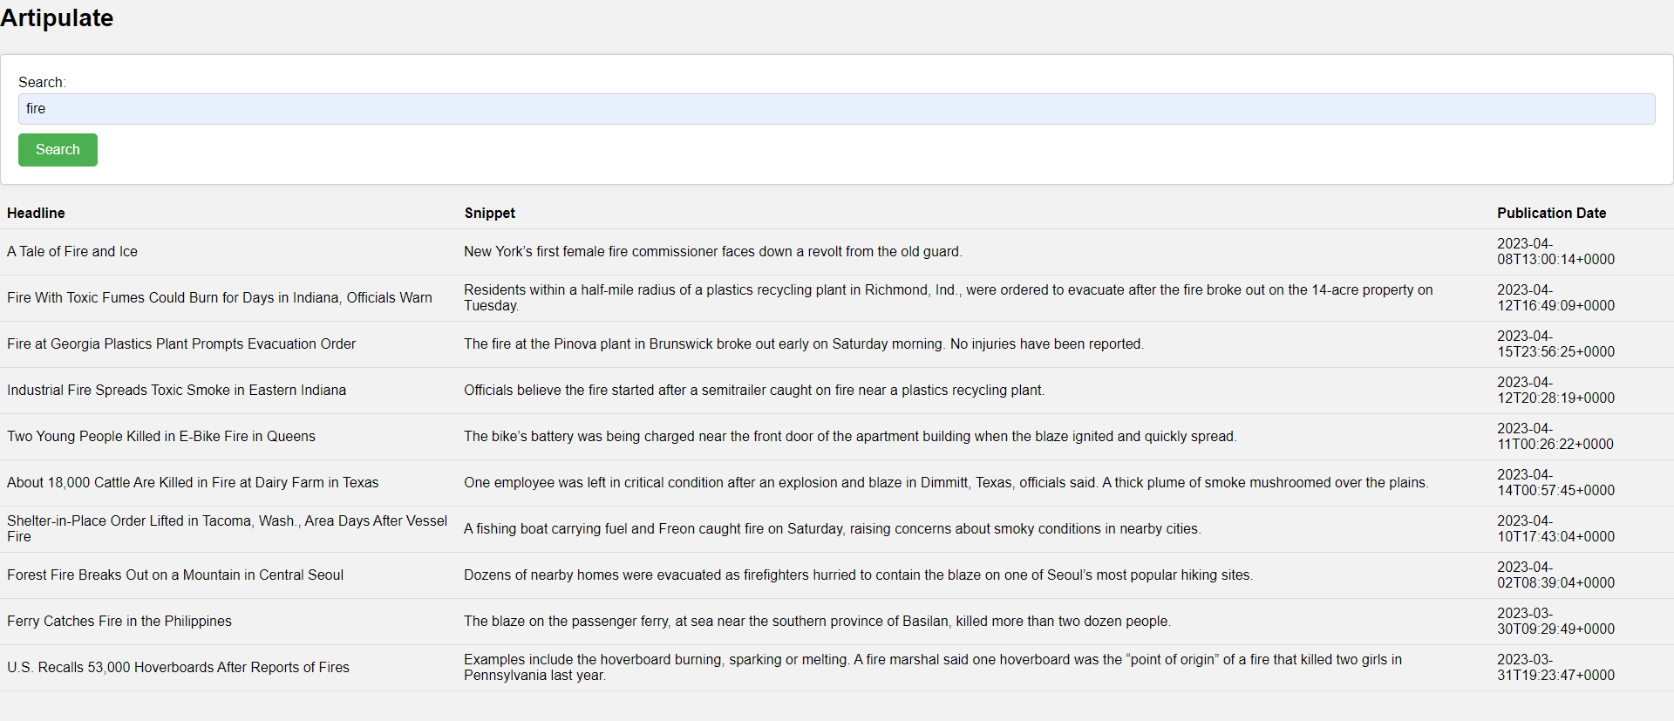

The URL that I tested is <https://api.nytimes.com/svc/search/v2/articlesearch.json>.

This is a GET method which fetches all the articles related to the keyword that is searched.

1. The JSON format of the Request body.

Since the request is a straightforward GET request with query parameters appended to the URL, there is no need for a Request body in this code.

1. The format of the Response body.

The response of the body is json which is then converted into html and the data is displayed in the webpage. The response body contains an array of documents, and each document has properties such as headline, snippet, and publication date.

1. The meaning/purpose of the received information.

The collected data is used to give the user access to the search results in a table format. The code analyzes the JSON response and extracts the pertinent data, including the article's title, snippet, and date of publication. Then it updates the table by adding each article's data as a new entry. The user may now browse and navigate the search results with ease.